1905387

CHAUDHARY HAMDAN

WT LAB ASSIGNMENT 2

Date : 15-01-2021

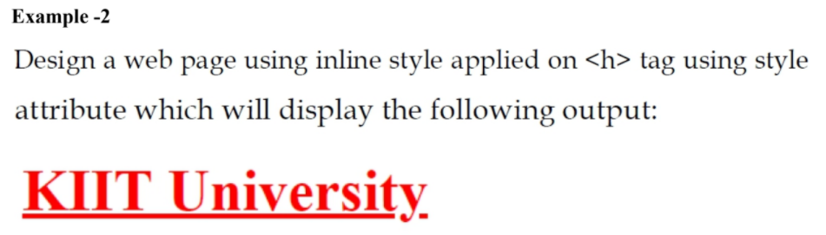

Code :

<!DOCTYPE html>

<html>

<head>

<title>Assignment 2 Q 2</title>

</head>

<body>

<h1 style="text-decoration: underline;color:red; ">KIIT University</h1>

</body>

</html>

Output :



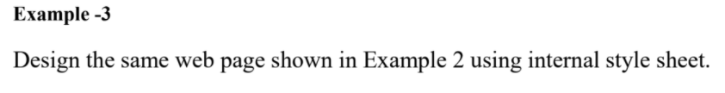

Code :

<!DOCTYPE html>

<html>

<head>

<title>Assignment 2 Q 3</title>

<style type="text/css">

h1 {

text-decoration: underline;

color:red;

}

</style>

</head>

<body>

<h1>KIIT University</h1>

</body>

</html>

Output :



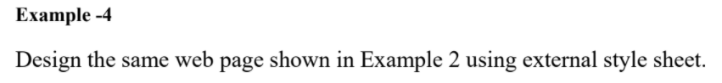

Code :

HTML :

<!DOCTYPE html>

<html>

<head>

<title>Assignment 2 Q 4</title>

<link rel="stylesheet" type="text/css" href="Assignment2Q4.css">

</head>

<body>

<h1>KIIT University</h1>

</body>

</html>

CSS :

h1 {

text-decoration: underline;

color:red;

}

Output :



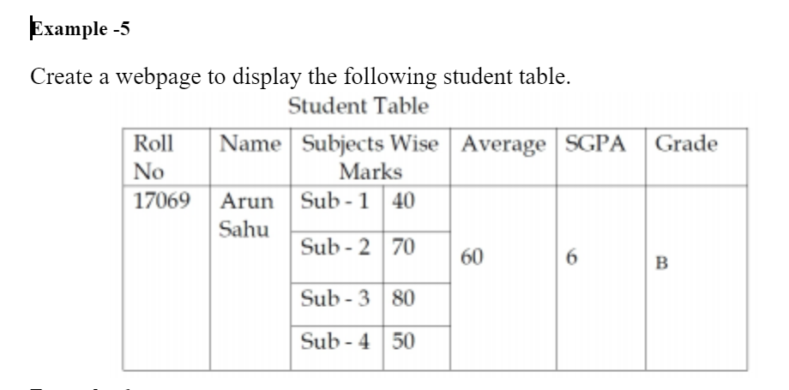

Code :

<!DOCTYPE html>

<html>

<head>

<title>Assignment 2 Q 5</title>

<style>

table, th, td {

border: 1px solid black;

border-collapse: collapse;

}

</style>

</head>

<body>

<center>Student Table</center>

<center>

<table >

<tr>

<td>Roll No</td>

<td>Name</td>

<td colspan="2">Subject Wise Marks</td>

<td>Average</td>

<td>SGPA</td>

<td>Grade</td>

</tr>

<tr>

<td rowspan="4">17069</td>

<td rowspan="4">Arun Sahu</td>

<td>Sub-1</td>

<td>40</td>

<td rowspan="4">60</td>

<td rowspan="4">6</td>

<td rowspan="4">B</td>

</tr>

<tr>

<td>Sub-2</td>

<td>70</td>

</tr>

<tr>

<td>Sub-3</td>

<td>80</td>

</tr>

<tr>

<td>Sub-4</td>

<td>50</td>

</tr>

</table>

</center>

</body>

</html>

Output :

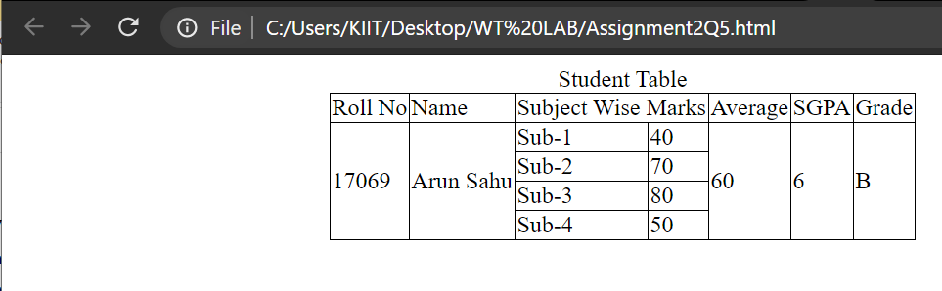

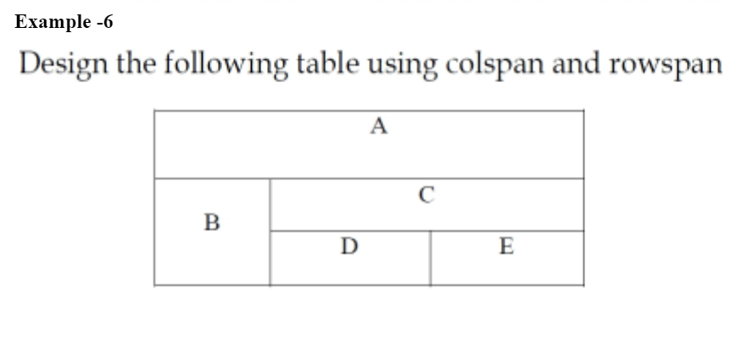

Code :

<!DOCTYPE html>

<html>

<head>

<title>Assignment 2 Answer 6</title>

<style>

table, th, td {

border: 1px solid black;

border-collapse: collapse;

}

</style>

</head>

<body>

<table>

<tr>

<td colspan="3">A </td>

</tr>

<tr>

<td rowspan="2"> B </td>

<td colspan="2"> <center>C <center></td>

</tr>

<tr>

<td>D </td>

<td>E </td>

</tr>

</table>

</body>

</html>

Output :

